SPRINT 3

TEAM ID: PNT2022TMID53558

REAL TIME RIVER QUALITY MONITORING AND CONTROL SYSTEM

DESIGN AN APP IN MIT APP INVENTOR PARAMETERS ARE:

1. **Ph**
2. **Water turbidity**
3. **Moisture**
4. **Salinity**
5. **Dissolved Oxygen**
6. **Nutrients**

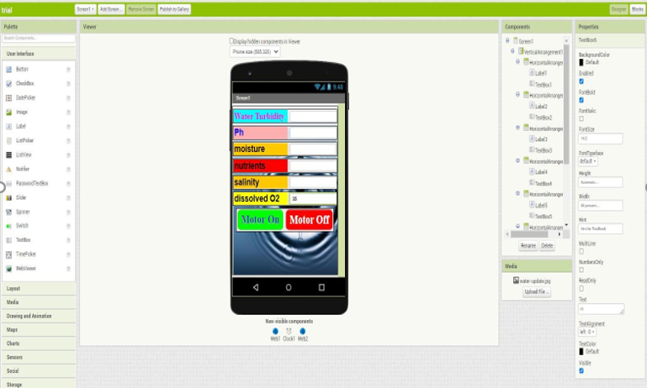

**FRAME THE BLOCKS FOR FUNCTIONING**

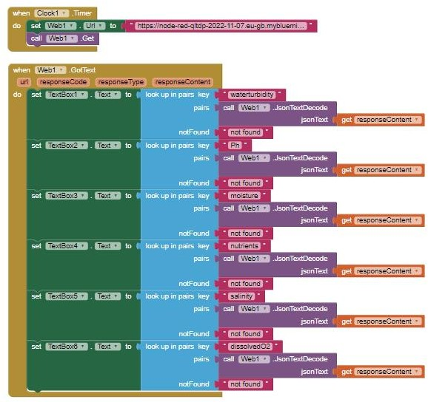

**FOR BUTTONS**

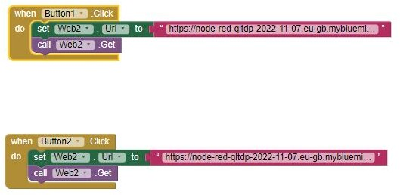

https://node-red-qltdp-2022-11-07.eu-gb.mybluemix.net/data



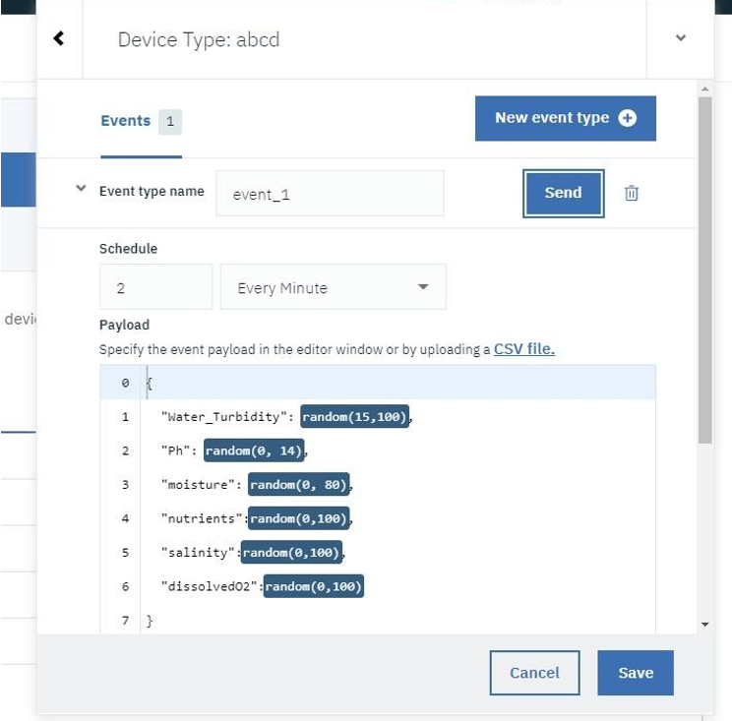

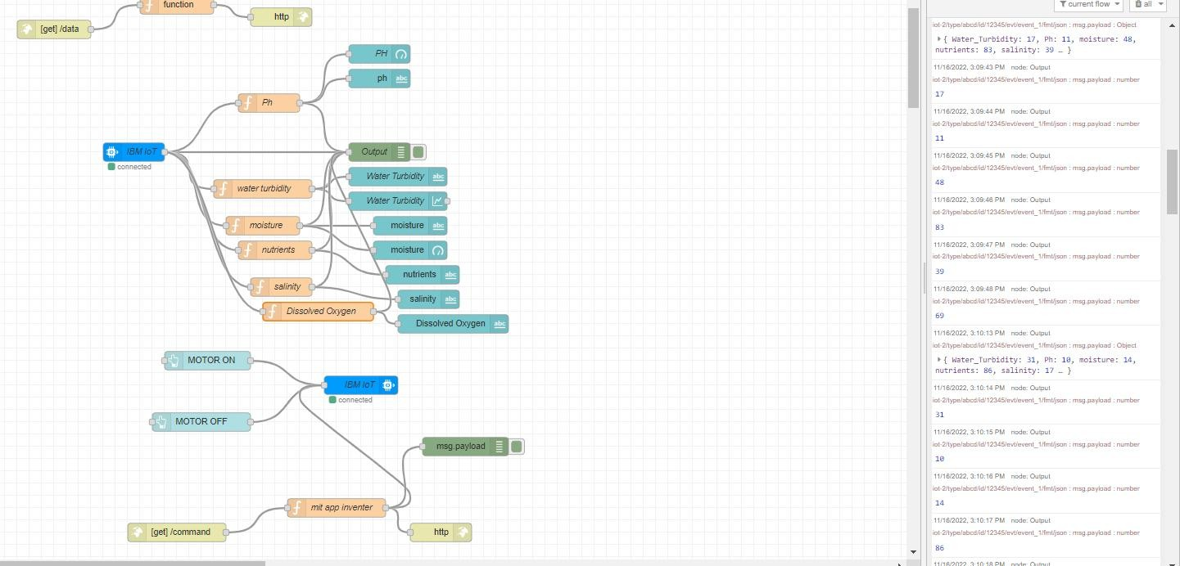

APP IN MOBILE

